# RGB LED Experiment

## Introduction to RGB leds

In this course, you will use PWM to control the RGB LED lights and make them display different colors.

When two leds are lit by three primary color leds, they can emit yellow, purple and cyan (such as red and blue leds). If red, green and blue leds are lit at the same time, they produce white light. If a circuit can make red, green, and blue leds light up in pairs, individually, and three primary leds light up at the same time, it can emit seven different colors of light, thus resulting in the phenomenon of colorful LED lights.

The color changing light is made up of red (R), green (G) and blue (B) leds. Two-color leds are very familiar to us. Generally consists of red LED and green LED. It can emit red or green light alone. When red and green light are both bright, the red and green light are mixed into orange. RGB is divided into common Yin and common Yang, the long pin is the common end, the other pins are as follows

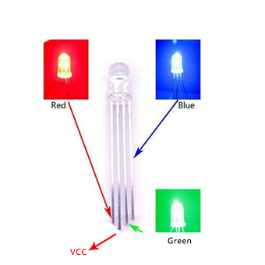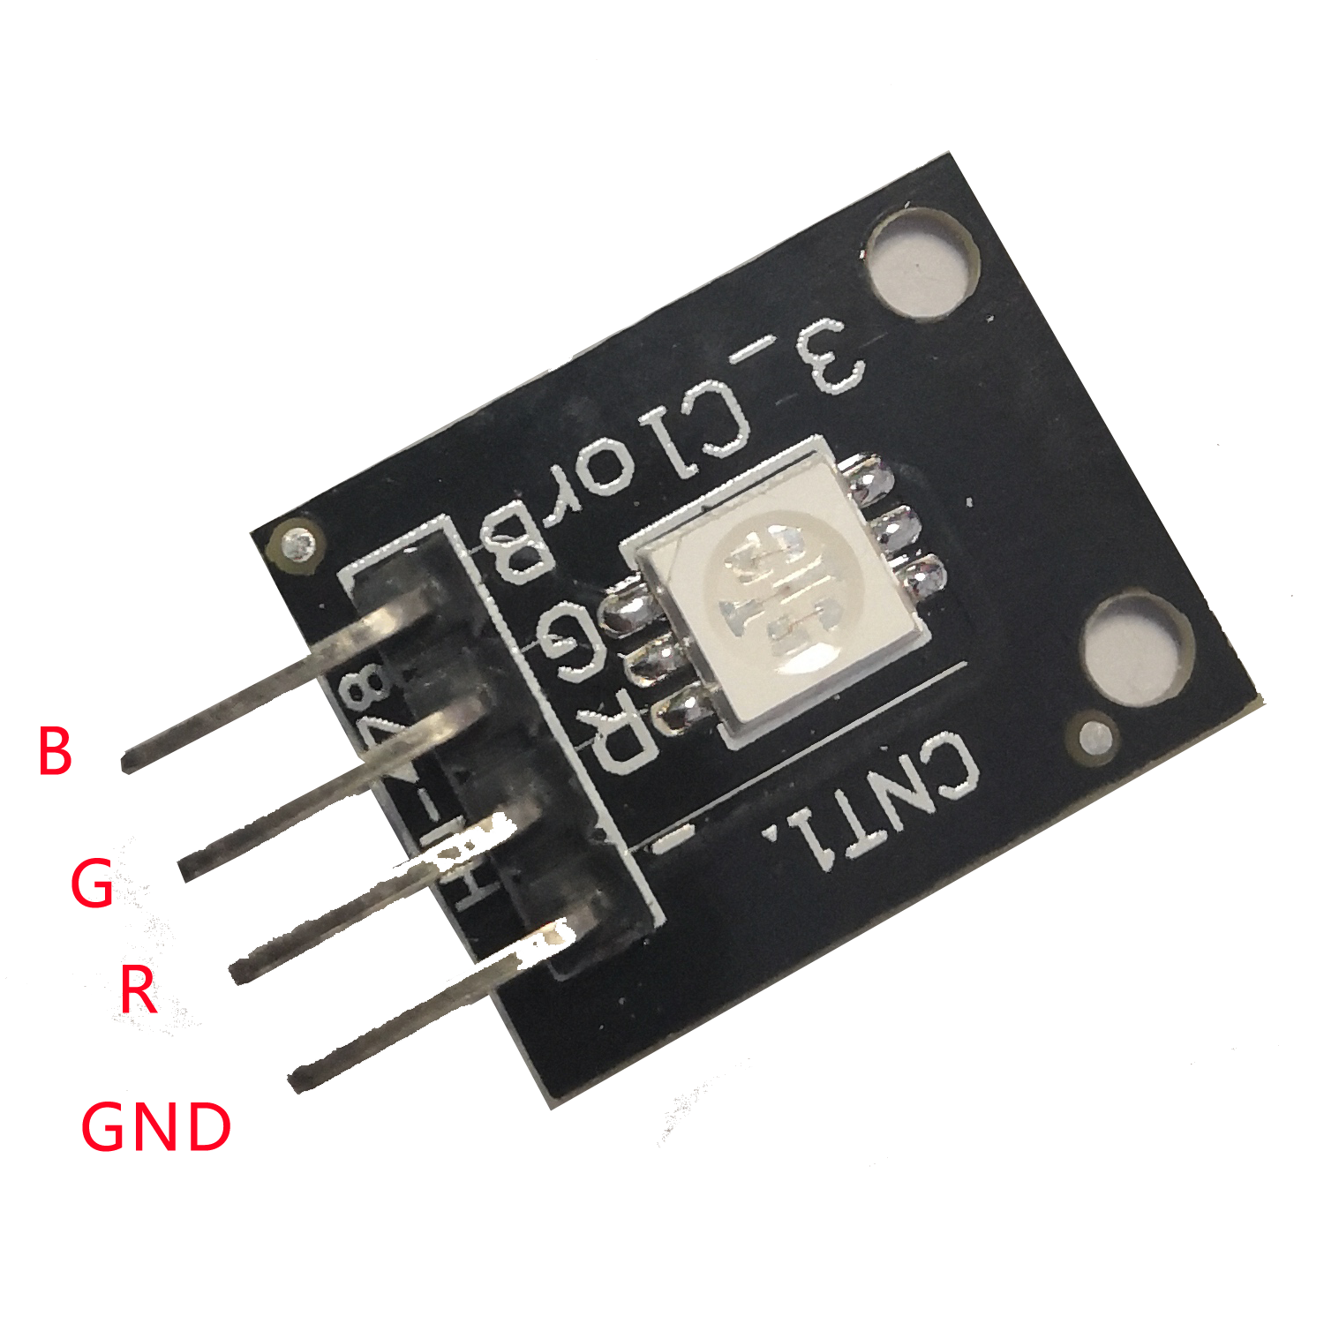

## 组件清单

* Raspberry Pi main board
* T type expansion board
* Breadboard
* power cable
* Common anode RGB LED*1
* Resistors (220Ω) *3
* Several jumper wires

## Experimental Principle

RGB stands for the red, green, and blue color channels, it is an industry color standard. RGB displays various new colors by changing the three channels and superimposing them, which, according to statistics, can create 16,777,216 different colors. If you say the color displayed doesn’t completely match a natural color, then it almost certainly cannot be differentiated with the naked eyes.

Each of the three color channels of red, green, and blue has 255 stages of brightness. When the three primary colors are all 0, "LED light" is the darkest, that is, it turns off. When the three primary colors are all 255, "LED light" is the brightest. When superimposing the light emitted by the three primary colors, the colors will be mixed. However, the brightness is equal to the sum of all brightness, and the more you mix, the brighter the LED is. This process is known as additive mixing.

In this experiment, we will also use PWM, if you’ve followed the lessons thus far, you,for sure, already have a basic understanding. Here we input a value between 0 and 255 to the three pins of the RGB LED to make it display different colors。

## 接线

|  |  |
| --- | --- |
| RaspberryPi | RGB |
| IO0(wiringPi)\17(BCM) | 1 |
| IO1(wiringPi)\18(BCM) | 3 |
| IO2(wiringPi)\27(BCM) | 4 |
| +5V | 2 |

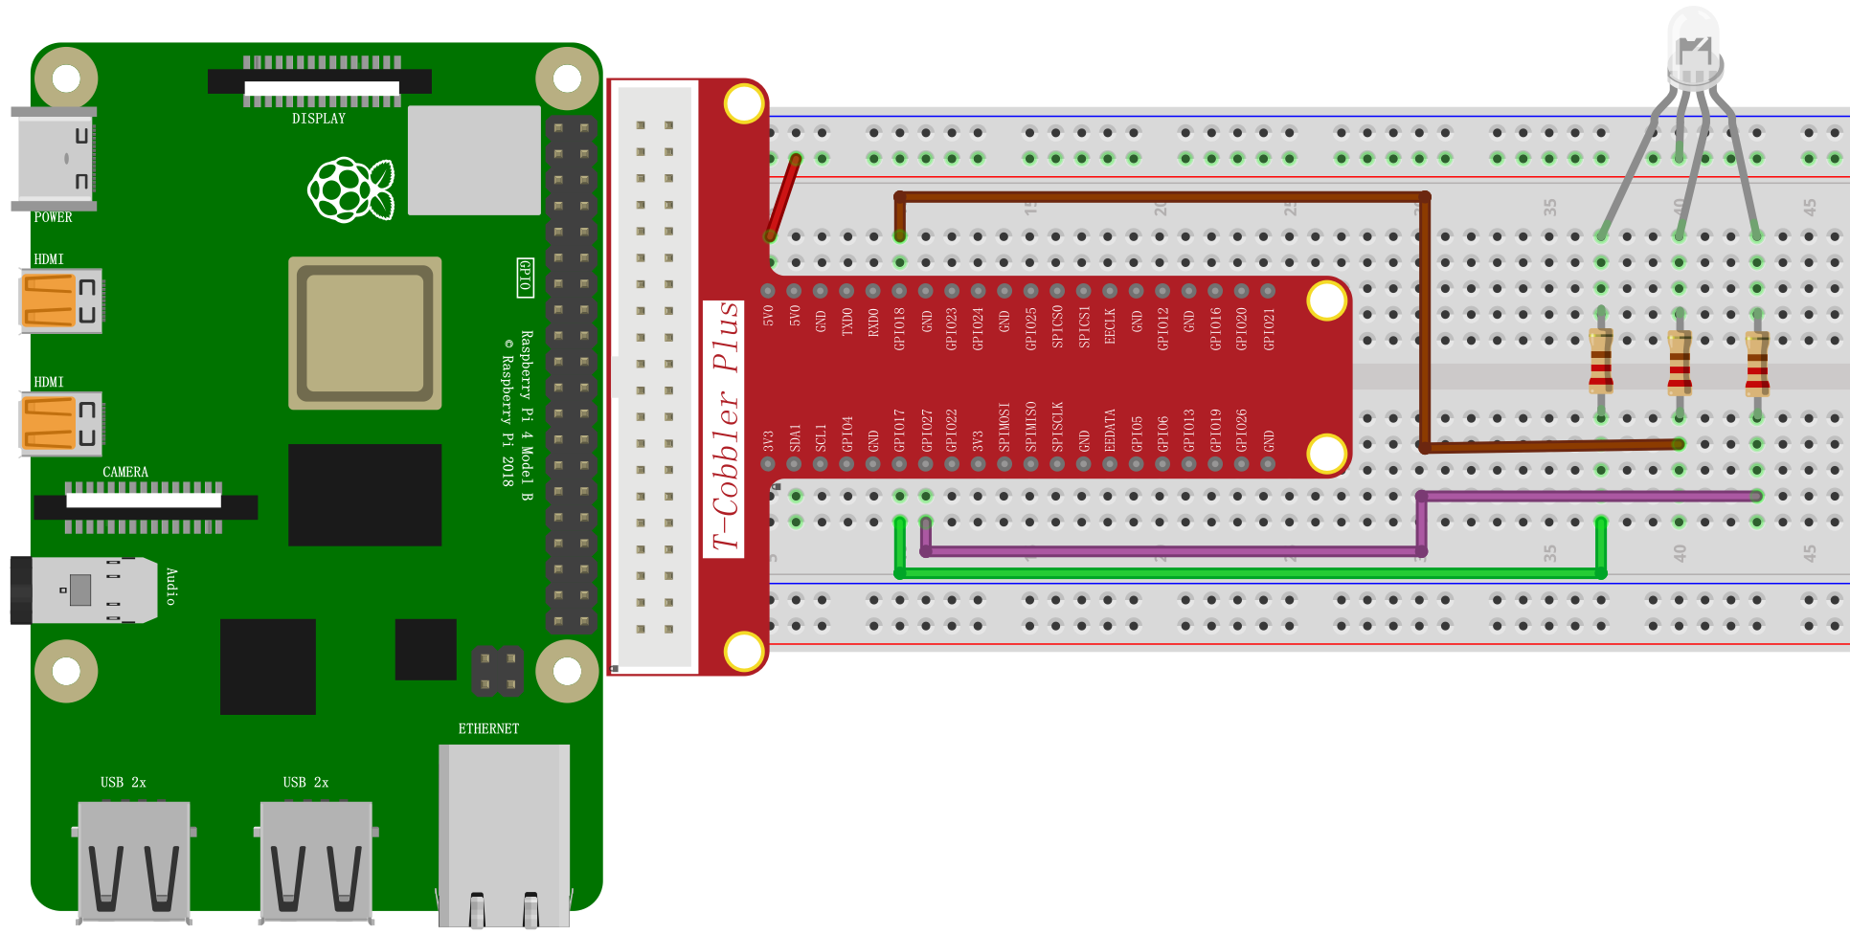

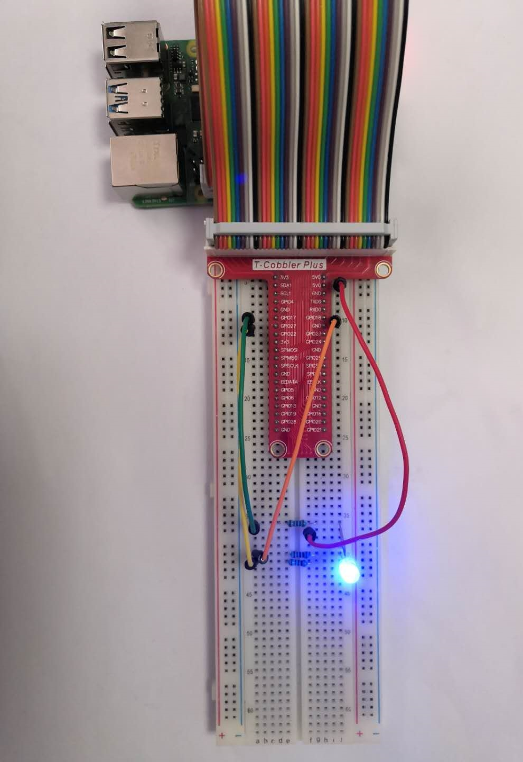

## C++ program

|  |
| --- |
| #include <wiringPi.h>  #include <softPwm.h>  #include <stdio.h>  #define uchar unsigned char  #define LedPinRed 0  #define LedPinGreen 1  #define LedPinBlue 2  void ledInit**(**void**)**  **{**  softPwmCreate**(**LedPinRed**,** 0**,** 100**);**  softPwmCreate**(**LedPinGreen**,**0**,** 100**);**  softPwmCreate**(**LedPinBlue**,** 0**,** 100**);**  **}**  void ledColorSet**(**uchar r_val**,** uchar g_val**,** uchar b_val**)**  **{**  softPwmWrite**(**LedPinRed**,** r_val**);**  softPwmWrite**(**LedPinGreen**,** g_val**);**  softPwmWrite**(**LedPinBlue**,** b_val**);**  **}**  int main**(**void**)**  **{**  **if(**wiringPiSetup**()** **==** **-**1**){** //when initialize wiring failed, print message to screen  printf**(**"setup wiringPi failed !"**);**  **return** 1**;**  **}**  ledInit**();**  **while(**1**){**  ledColorSet**(**0xff**,** 0x00**,** 0x00**);** //red  delay**(**500**);**  ledColorSet**(**0x00**,** 0xff**,** 0x00**);** //green  delay**(**500**);**  ledColorSet**(**0x00**,** 0x00**,** 0xff**);** //blue  delay**(**500**);**  ledColorSet**(**0xff**,** 0xff**,** 0x00**);** //yellow  delay**(**500**);**  ledColorSet**(**0xff**,** 0x00**,** 0xff**);** //pick  delay**(**500**);**  ledColorSet**(**0xc0**,** 0xff**,** 0x3e**);**  delay**(**500**);**  ledColorSet**(**0x94**,** 0x00**,** 0xd3**);**  delay**(**500**);**  ledColorSet**(**0x76**,** 0xee**,** 0x00**);**  delay**(**500**);**  ledColorSet**(**0x00**,** 0xc5**,** 0xcd**);**  delay**(**500**);**  **}**  **return** 0**;**  **}** |

## Python program

|  |
| --- |
| #!/usr/bin/env python  import RPi**.**GPIO as GPIO  import time  colors **=** **[**0xFF0000**,** 0x00FF00**,** 0x0000FF**,** 0xFFFF00**,** 0xFF00FF**,** 0x00FFFF**]**  R **=** 17  G **=** 18  B **=** 27  def setup**(**Rpin**,** Gpin**,** Bpin**):**  global pins  global p_R**,** p_G**,** p_B  pins **=** **{**'pin_R'**:** Rpin**,** 'pin_G'**:** Gpin**,** 'pin_B'**:** Bpin**}**  GPIO**.**setmode**(**GPIO**.**BCM**)**  **for** i in pins**:**  GPIO**.**setup**(**pins**[**i**],** GPIO**.**OUT**)** # Set pins' mode is output  GPIO**.**output**(**pins**[**i**],** GPIO**.**HIGH**)** # Set pins to high**(+**3.3V**)** to off led    p_R **=** GPIO**.**PWM**(**pins**[**'pin_R'**],** 2000**)** # set Frequece to 2KHz  p_G **=** GPIO**.**PWM**(**pins**[**'pin_G'**],** 1999**)**  p_B **=** GPIO**.**PWM**(**pins**[**'pin_B'**],** 5000**)**    p_R**.**start**(**100**)** # Initial duty Cycle **=** 0**(**leds off**)**  p_G**.**start**(**100**)**  p_B**.**start**(**100**)**  def map**(**x**,** in_min**,** in_max**,** out_min**,** out_max**):**  **return** **(**x **-** in_min**)** **\*** **(**out_max **-** out_min**)** **/** **(**in_max **-** in_min**)** **+** out_min  def off**():**  **for** i in pins**:**  GPIO**.**output**(**pins**[**i**],** GPIO**.**HIGH**)** # Turn off all leds  def setColor**(**col**):** # For example **:** col **=** 0x112233  R_val **=** **(**col **&** 0xff0000**)** **>>** 16  G_val **=** **(**col **&** 0x00ff00**)** **>>** 8  B_val **=** **(**col **&** 0x0000ff**)** **>>** 0  R_val **=** map**(**R_val**,** 0**,** 255**,** 0**,** 100**)**  G_val **=** map**(**G_val**,** 0**,** 255**,** 0**,** 100**)**  B_val **=** map**(**B_val**,** 0**,** 255**,** 0**,** 100**)**    p_R**.**ChangeDutyCycle**(**100**-**R_val**)** # Change duty cycle  p_G**.**ChangeDutyCycle**(**100**-**G_val**)**  p_B**.**ChangeDutyCycle**(**100**-**B_val**)**  def loop**():**  **while** True**:**  **for** col in colors**:**  setColor**(**col**)**  time**.**sleep**(**1**)**  def destroy**():**  p_R**.**stop**()**  p_G**.**stop**()**  p_B**.**stop**()**  off**()**  GPIO**.**cleanup**()**  **if** __name__ **==** "__main__"**:**  **try:**  setup**(**R**,** G**,** B**)**  loop**()**  except KeyboardInterrupt**:**  destroy**()** |

## Java program

|  |
| --- |
| **import** com**.**pi4j**.**wiringpi**.**Gpio**;**  **import** com**.**pi4j**.**wiringpi**.**SoftPwm**;**  public class RGB_lamp **{**  int LedPinRed **=** 0**,** LedPinGreen **=** 1**,** LedPinBlue **=** 2**;**  void ledInit**()** **{**  SoftPwm**.**softPwmCreate**(**LedPinRed**,** 0**,** 100**);**  SoftPwm**.**softPwmCreate**(**LedPinGreen**,**0**,** 100**);**  SoftPwm**.**softPwmCreate**(**LedPinBlue**,** 0**,** 100**);**  **}**    void ledColorSet**(**int r_val**,** int g_val**,** int b_val**)** **{**  SoftPwm**.**softPwmWrite**(**LedPinRed**,** r_val**);**  SoftPwm**.**softPwmWrite**(**LedPinGreen**,** g_val**);**  SoftPwm**.**softPwmWrite**(**LedPinBlue**,** b_val**);**  **}**  public static void main**(**String**[]** args**)** **{**  **if(**Gpio**.**wiringPiSetup**()** **==** **-**1**){** //when initialize wiring failed, print message to screen  System**.**out**.**println**(**"setup wiringPi failed !"**);**  **return** **;**  **}**  RGB_lamp rgb_lamp **=** **new** RGB_lamp**();**  rgb_lamp**.**ledInit**();**    **while(true)** **{**  rgb_lamp**.**ledColorSet**(**0xff**,**0x00**,**0x00**);** //red  Gpio**.**delay**(**500**);**  rgb_lamp**.**ledColorSet**(**0x00**,**0xff**,**0x00**);** //green  Gpio**.**delay**(**500**);**  rgb_lamp**.**ledColorSet**(**0x00**,**0x00**,**0xff**);** //blue  Gpio**.**delay**(**500**);**    rgb_lamp**.**ledColorSet**(**0xff**,**0xff**,**0x00**);** //yellow  Gpio**.**delay**(**500**);**  rgb_lamp**.**ledColorSet**(**0xff**,**0x00**,**0xff**);** //pick  Gpio**.**delay**(**500**);**  rgb_lamp**.**ledColorSet**(**0xc0**,**0xff**,**0x3e**);**  Gpio**.**delay**(**500**);**    rgb_lamp**.**ledColorSet**(**0x94**,**0x00**,**0xd3**);**  Gpio**.**delay**(**500**);**  rgb_lamp**.**ledColorSet**(**0x76**,**0xee**,**0x00**);**  Gpio**.**delay**(**500**);**  rgb_lamp**.**ledColorSet**(**0x00**,**0xc5**,**0xcd**);**  Gpio**.**delay**(**500**);**  **}**  **}**  **}** |

## Experimental results

Here you should see the RGB LED flashing in a circle, first red, then green and blue.